
Company
Logotype

Cone Beam Computed Tomography- Report



Porur Dental X-rays & CBCT

Patient Name : Mrs. Rameja | Date of Report : 08.08.2024
Age/ Gender : 35 years/ Female | Region of Interest : CBCT Sectional Mandible
Referring doctor: Dr. Geno’s Dental Clinic | Indication : Implant assessment
Clinical Notes: Nil
PATIENT INFORMATION

CBCT- Sectional Mandible provided
CBCT – IMAGE DETAILS

RADIOGRAPHIC INTERPRETATION

- In relation to the interdental aspect of 35, 36, presence of bone loss in an irregular and angular pattern, extending upto and beyond the middle third of its root.
- Presence of resorptive changes of the root of 35 is evident.
- Crestal bone loss evident in relation to 34.
- Hyperdense restorative material in relation to 36, 37 is evident.

IMPLANT ASSESSMENT

 | 34 region | 35 region
Sub-Crestal (in mm) | 6.73 | 8.68
Mid- Crestal (in mm) | 7.88 | 9.09
Distance between alveolar ridge and the inferior border of mandible (in mm) | - | 8.75
Distance between distal portion of 45 and mesial portion of 47  (in mm) | 20.5 | 18.65

RADIOGRAPHIC IMPRESSION

- Chronic periodontitis in relation to 34, 35 region.
- Restored teeth: 36, 37

Kindly correlate with clinical findings


IMAGES FOR REFERENCE

RECONSTRUCTED PANORAMIC VIEW
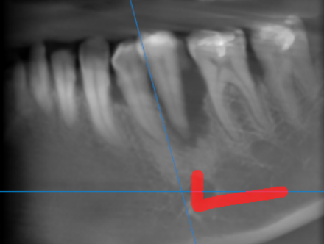

3-DIMENSIONAL VIEW

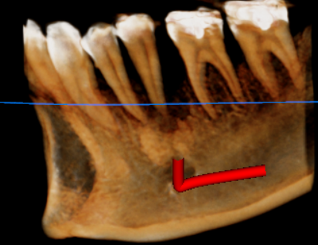

CROSS SECTIONAL VIEW

34 region | 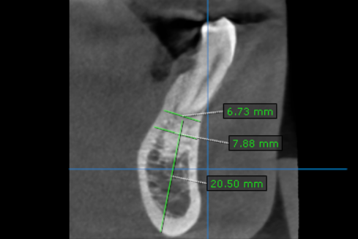
35 region | 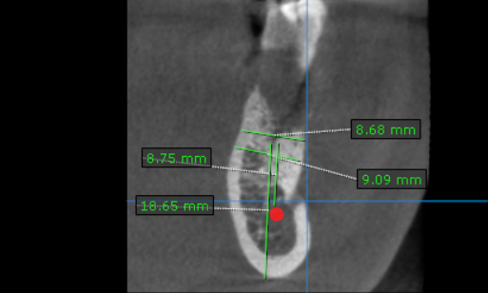

**** End of report ****

